* 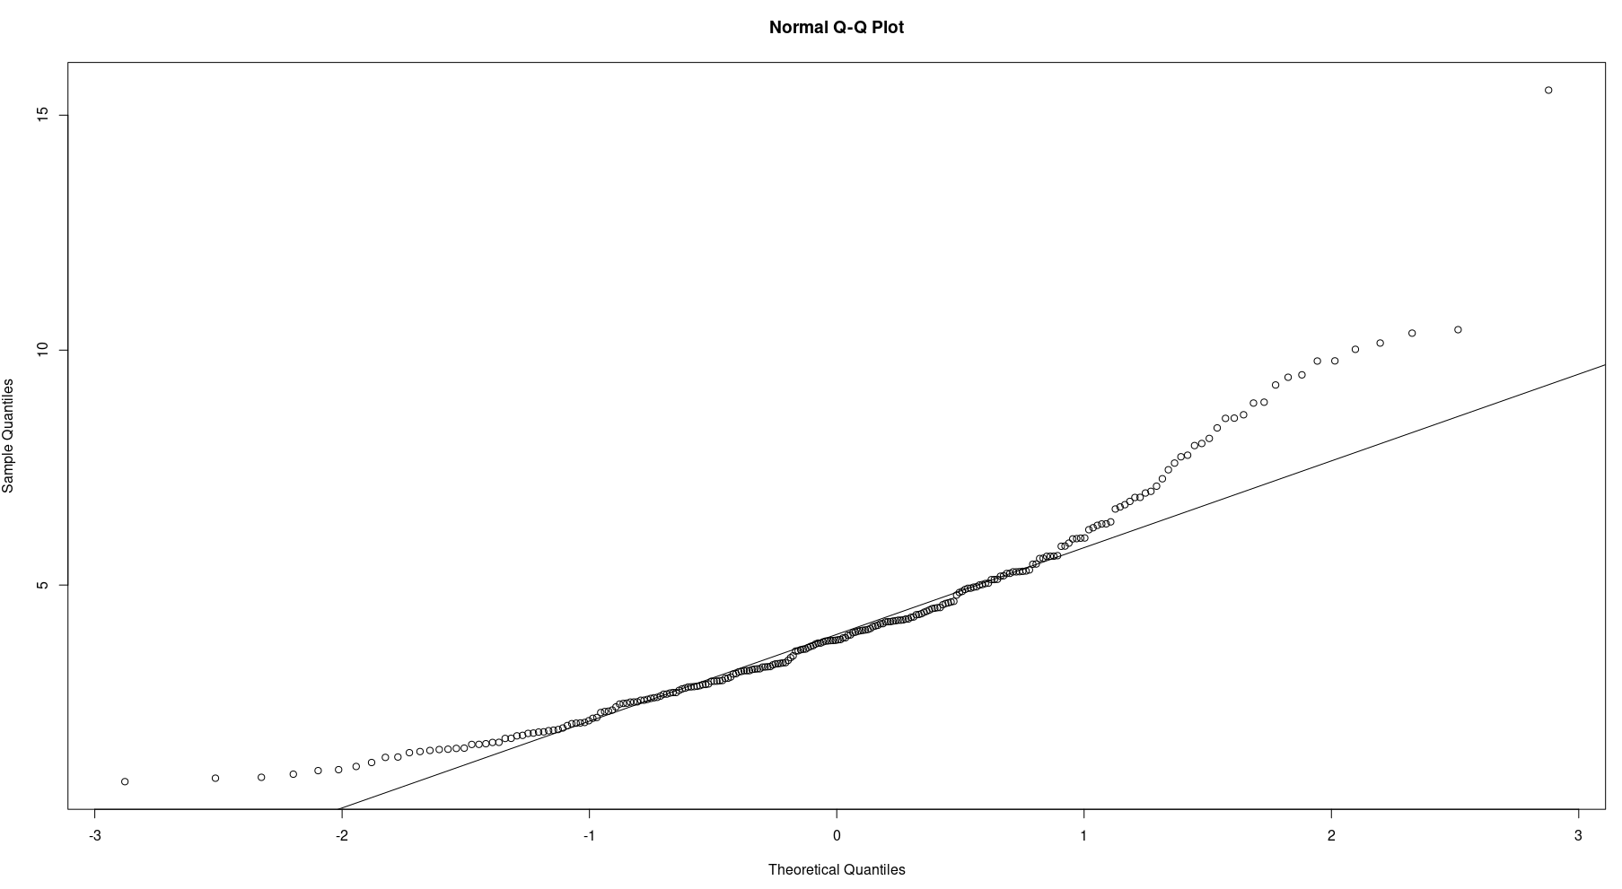From the above quartile plot and quartile line plot it can be seen that the data is not normally distributed.